**CENTRE FOR DIPLOMA STUDIES**

**UNIVERSITI TUN HUSSEIN ONN MALAYSIA (UTHM)**

**LAB 6**

**DATABASE & SQL**

**COURSE CODE         DAT21303**

**COURSE NAME        WEB DEVELOPMENT**

**FACULTY                  CENTER OF DIPLOMA STUDY**

**DEPARTMENT OF INFORMATION TECHNOLOGY**

**STUDENT NAME     WAN MUHAMMAD ALIF FIRDAUS BIN WAN HANAPI**

**NUM MATRIX AA210292**

**SECTION                   6**

**LECTURE NAME    NOR NADHIA BINTI NOR AZMAN SUBRAMANIAM**

**SUBMIT DATE          3 JANUARY 2023**

**LABORATORY 6: DATABASE & MySQL**

|  |  |
| --- | --- |
| **Objective** | Student would be able to understand database operation by using PhpMyadmin and also able to manipulate variables from HTML form by using PHP and SQL scripting. |
| **Required**  **Resources** | Macromedia Dreamweaver, Sublime Text, Bracket or if you are good enough just use text editor notepad. Xampp (used to dedicate your machine as server). |
| **References** | https://www.w3schools.com/php/php_mysql_intro.asp http://www.sqlcourse.com/table.html |
| **Date**  **Released** | 22/10/2017 |
| **Date**  **Submission** | 29/10/2017 |

Note: Do this Lab in a group of two people

**i. Why used database management system?**

A database management system is important because it manages data efficiently and allows users to perform multiple tasks with ease. A database management system stores, organizes and manages a large amount of information within a single software application

# Why we need PHP and SQL scripting

PHP is the most popular scripting language for web development. It is free, open source and server-side (the code is executed on the server). MySQL is a Relational Database Management System (RDBMS) that uses Structured Query Language (SQL). Both are so important to be used in order to manage any system development related to web based. **iii. PhpMyadmin**

PhpMyadmin is a free and open source administration tool for MySQL and MariaDB. As a portable web application written primarily in PHP, it has become one of the most popular MySQL administration tools, especially for web hosting services

**Question 1:** Create a new database name as UTHMPagoh and a new table in PhpMyadmin. The table must be created according to Table 1.0 below. By using PHP and SQL scripting:

* Insert five new record into Student table
* Update record student which is score greater than 30
* Search and display all records
* Set Id to primary key and auto increment
* Count the rows of available record of Student Table  Delete record where state = Penang

**Table 1.0: Student Table**

|  |  |  |  |  |
| --- | --- | --- | --- | --- |
| **Id** | **Names** | **Ages** | **States** | **Scores** |
|  |  |  |  |  |
| 1 | Gabriel | 20 | Kedah | 30 |
| 2 | Michael | 12 | Penang | 10 |
| 3 | Ronaldo | 13 | Perak | 98 |
| 4 | Reberto | 22 | Perak | 76 |

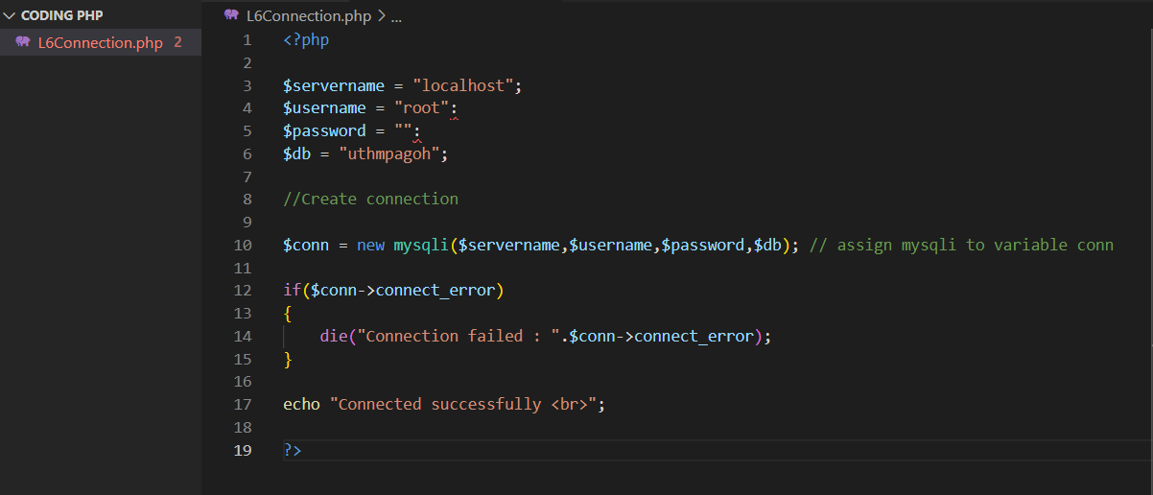

.CREATE FILE TO CONNECTION CODE

This PHP script is used to establish a connection to a MySQL database.The first four lines of the script define variables for the server name, username, password, and database name that are needed to connect to the database. The server name is usually "localhost" if the database is hosted on the same server as the PHP script.

The next line creates a new mysqli object and assigns it to the variable $conn. The mysqli object is used to connect to a MySQL database using the four variables defined earlier.

The if statement is used to check if the connection was successful. If the connection fails, the script will display an error message and stop execution. If the connection is successful, the script will print "Connected successfully" and continue executing.

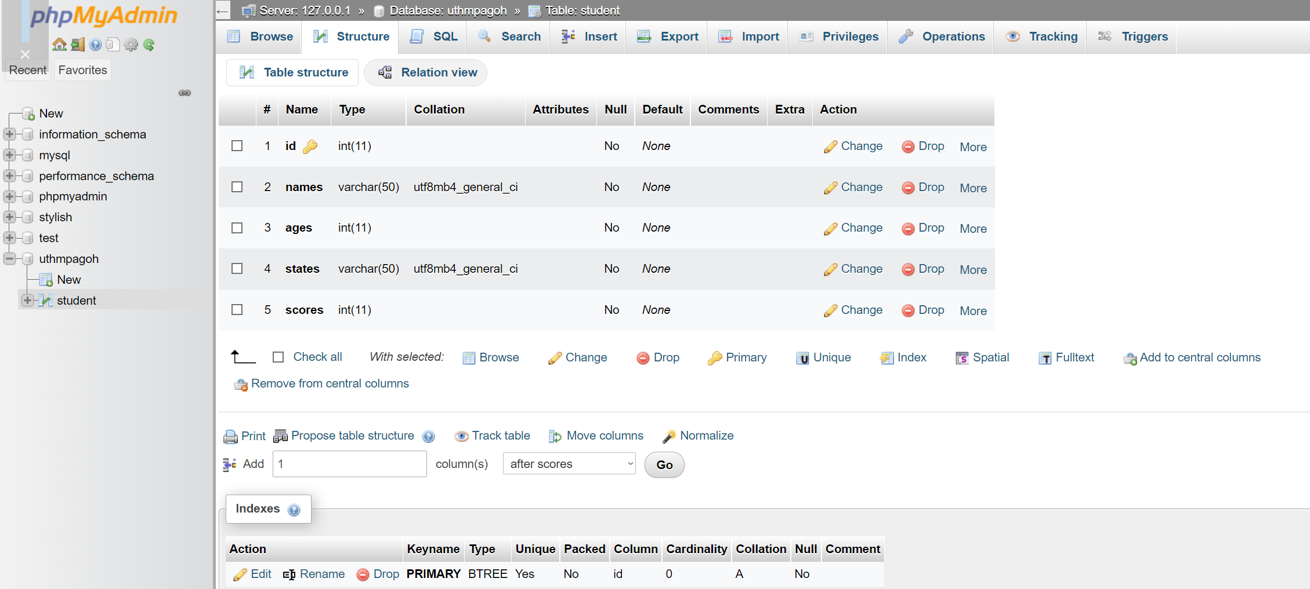

.Set id to primary key

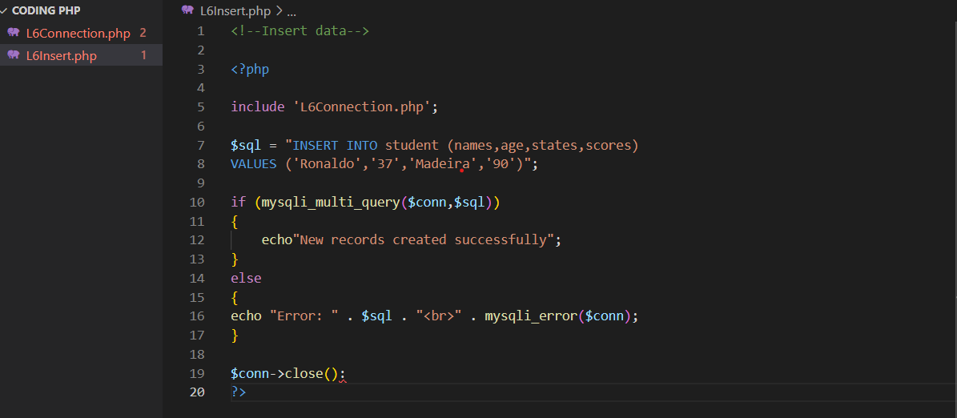

.Create new file to insert data to database

This PHP script is used to insert data into a MySQL database.The first line includes a file called "L6Connection.php", which is assumed to contain code for connecting to a MySQL database.

The next line defines a variable called $sql that contains an SQL INSERT statement. This statement is used to insert a new record into a table called "student", with values for the columns "names", "age", "states", and "scores".

The mysqli_multi_query() function is then used to execute the SQL INSERT statement. If the query is successful, the script will print "New records created successfully". If the query fails, it will print an error message.

Finally, the script closes the MySQL connection using the close() method of the mysqli object.



.The page

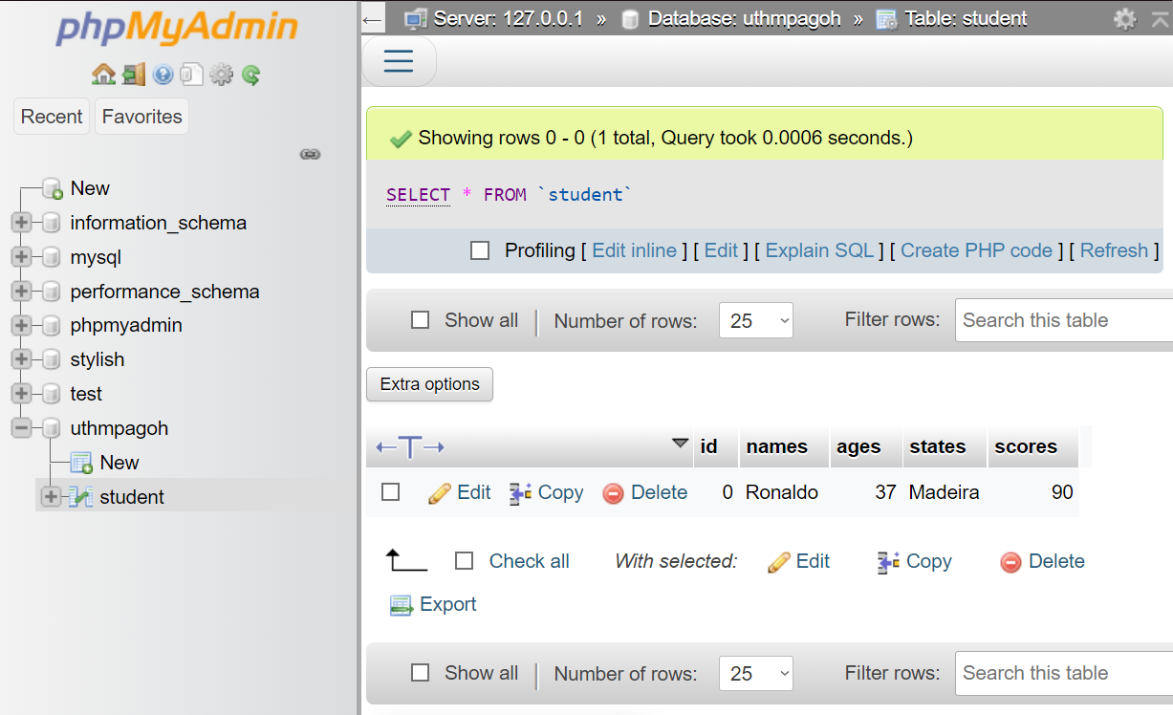

.Successfully insert data to database

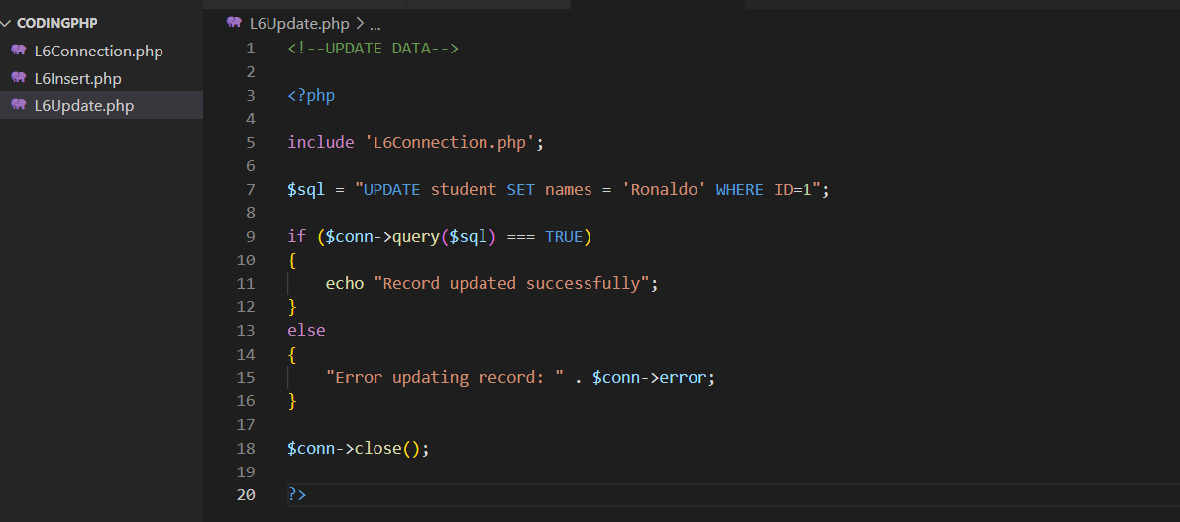

**6**.Create new file to update the data in database

This PHP script is used to update data in a MySQL database.he first line includes a file called "L6Connection.php", which is assumed to contain code for connecting to a MySQL database.

The next line defines a variable called $sql that contains an SQL UPDATE statement. This statement is used to update a record in a table called "student", specifically the record with an ID of 1. The statement sets the value of the "names" column to "Ronaldo".

The query() method of the mysqli object is then used to execute the SQL UPDATE statement. If the query is successful, the script will print "Record updated successfully". If the query fails, it will print an error message.

Finally, the script closes the MySQL connection using the close() method of the mysqli object.



.The page

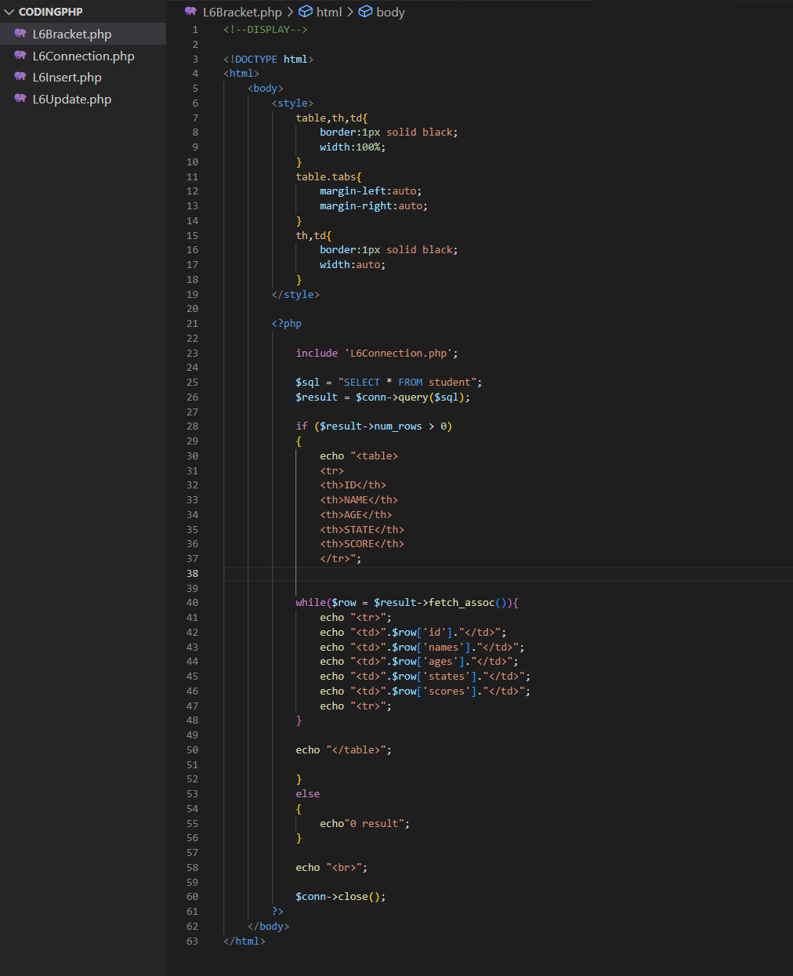

.create new file to make table

This PHP script is used to display data from a MySQL database in an HTML table.The first part of the script consists of an HTML page with a style section that defines the formatting for the table.

The second part of the script is the PHP code, which starts with the inclusion of the file "L6Connection.php", which is assumed to contain code for connecting to a MySQL database.

The next line defines a variable called $sql that contains an SQL SELECT statement. This statement is used to select all records from a table called "student".

The query() method of the mysqli object is then used to execute the SQL SELECT statement and store the result in a variable called $result.

The script then checks if there are any records in the result using the num_rows property of the $result object. If there are no records, it prints "0 result". If there are records, it prints an HTML table with the column names "ID", "NAME", "AGE", "STATE", and "SCORE", and then uses a while loop to iterate through the rows of the result and print the values of each column.

Finally, the script closes the MySQL connection using the close() method of the mysqli object.

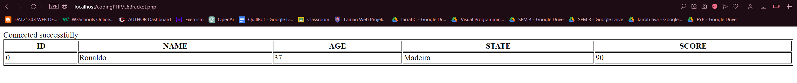

.table

**Question 2:** Create another Table name as “personal” in database UTHMPagoh. And then create a form name as “Form1.php” such shown in Figure 1.0 below. Attach all buttons with function “Save”, “Reset”, “Search”, “Update” and “Delete” by using PHP and SQL. Before doing any request to database a connection must be created. Your connection should be in another file name as “connection.php” and the file can be imported in “Form1.php” by using include function.

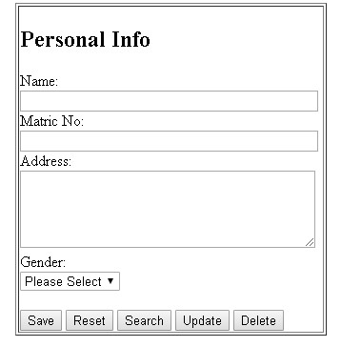

**Figure 1.0: Form1.php**

<!doctype html>

<html>

<head>

<meta charset="utf-8">

<title> Personal Info </title>

</head>

<body>

<style>

table.center {

margin-left: auto;

margin-right: auto;

}

body{

place-items:center;

text-align:center;

}

</style>

<!--FORM PERSONAL INFO-->

<br>

<table class="center" border="4px" bordercolor = "black">

<tr>

<td >

<table>

<form method="POST">

<tr> <th colspan="2"> Personal Info<br><br> </th> </tr>

<tr>

<td><label for="name">Your name:</label><br></td>

</tr>

<td><input type="text" id="name" name="name" required/><br><br><td>

</tr>

<tr>

<td><label for="password">Your Password:</label><br></td>

</tr>

<td><input type="password" id="psw" placeholder="password"

pattern="(?=.*\d)(?=.*[a-z])(?=.*[A-Z]).{8,}"

title="Must contain at least one number and one

uppercase and lowercase letter, and at least 8 or more characters" required/><br/><br/><td>

</tr>

<tr>

<td><label for ="Matricno">Your Matric Number:</label><br></td>

</tr>

<tr>

<td><input type="text" id="name" name="Matricno" required/><br><br><td>

</tr>

<tr>

<td>Address:</td>

</tr>

<tr>

<td><textarea name = "address" rows = "5" cols = "40"></textarea></td>

</tr>

<tr>

<td>Gender:</td>

</tr>

<tr>

<td>

<label for="gender"></label>

<select id="gender" name="gender">

<option value="male">Male</option>

<option value="female">Female</option>

</select>

</td>

</tr>

<tr>

<td><br>

<input type = "submit" name = "save" value = "Save">

<input type = "submit" name = "reset" value = "Reset">

<input type = "submit" name = "search" value = "Search">

<input type = "submit" name = "update" value = "Update">

<input type = "submit" name = "delete" value = "Delete">

</td>

</tr>

</form>

</table>

</td>

</table>

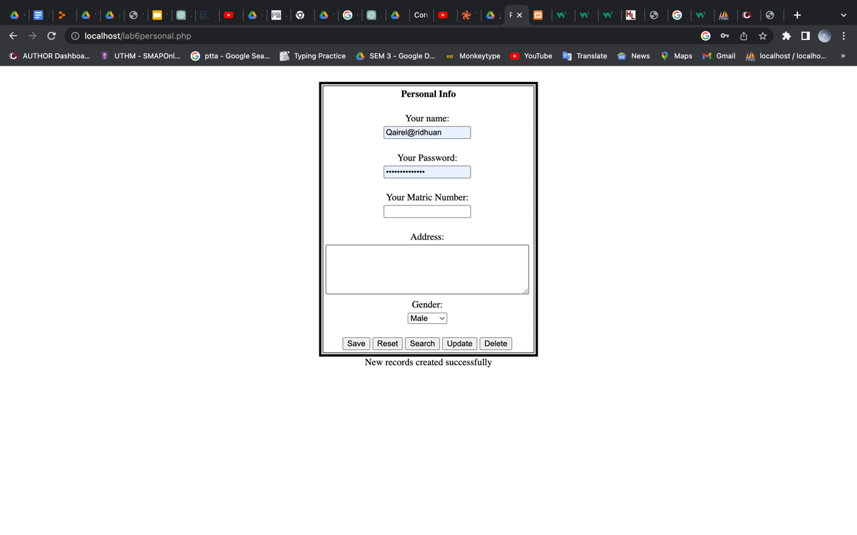

**SAVE DATA**

<?php

include "lab6connection.php"; // Using database connection file here

/*<!--SAVE DATA--> */

if(isset($_POST['save']))

{

$name = $_POST['name'];

$matric = $_POST['Matricno'];

$address = $_POST['address'];

$gender = $_POST['gender'];

$insert = "INSERT INTO personal (`name`, `Matricno`,`address`,`gender`) VALUES ('$name','$matric','$address','$gender')";

if (mysqli_multi_query($conn, $insert)) {

echo "New records created successfully";

} else {

echo "Error: " . $insert . "<br>" . mysqli_error($conn);

}

$conn->close(); // Close connection

}

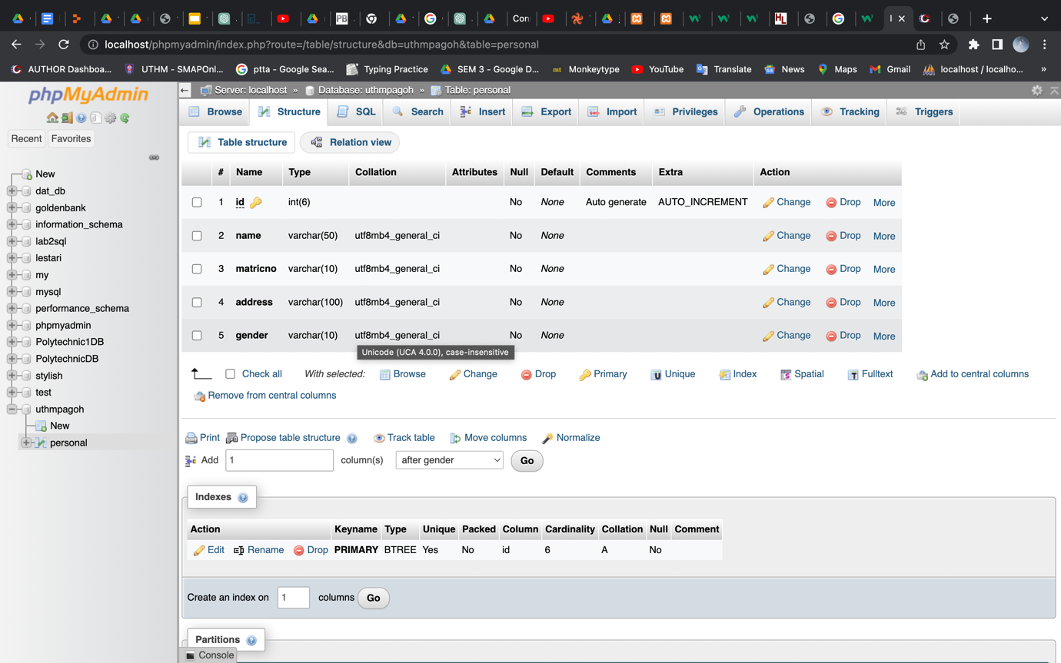

**RESET DATA**

/*RESET DATA*/

if(isset($_POST['reset']))

{

$name = $_POST['name'];

$matric = $_POST['Matricno'];

$address = $_POST['address'];

$gender = $_POST['gender'];

$reset = "UPDATE personal SET address='$address',gender='$gender' WHERE name='$name'AND Matricno='$matric'";

if (mysqli_multi_query($conn, $reset)) {

echo "New records successfully reseted";

} else {

echo "Error: " . $reset . "<br>" . mysqli_error($conn);

}

$conn->close(); // Close connection

}

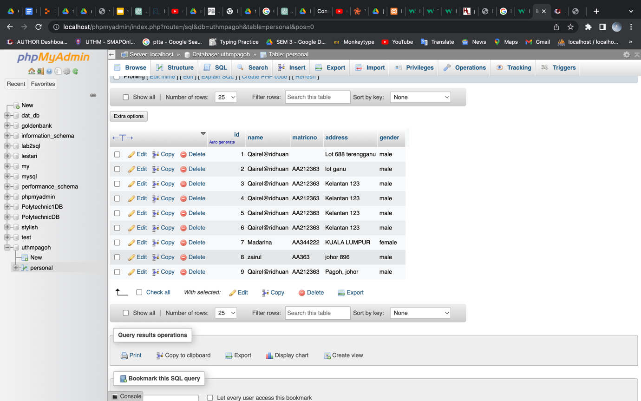

**SEARCH DATA**

/*SEARCH DATA*/

if(isset($_POST['search']))

{

$name = $_POST['name'];

$matric = $_POST['matric'];

$address = $_POST['address'];

$gender = $_POST['gender'];

if($name && $matric){

$search = "SELECT * FROM personal WHERE name='$name'AND matric='$matric'";

$result=$conn->query($search);

echo "<table>

<tr>

<th>ID</th>

<th>NAME</th>

<th>MATRIC NO</th>

<th>ADDRESS</th>

<th>GENDER</th>

</tr>";

if ($result = $conn->query($search)){

while ($row = $result->fetch_assoc()) {

echo "<tr>";

echo "<td>" . $row['id'] . "</td>";

echo "<td>" . $row['name'] . "</td>";

echo "<td>" . $row['matric'] . "</td>";

echo "<td>" . $row['address'] . "</td>";

echo "<td>" . $row['gender'] . "</td>";

echo "</tr>";

}

echo "</table>";

}

else{

echo "0 search result";

}

$conn->close(); // Close connection

}

}

**UPDATE DATA**

/*UPDATE DATA*/

if(isset($_POST['update']))

{

$name = $_POST['name'];

$matric = $_POST['matric'];

$address = $_POST['address'];

$gender = $_POST['gender'];

$update = "UPDATE personal SET address='$address',gender='$gender' WHERE name='$name' AND matric='$matric'";

if (mysqli_multi_query($conn, $update)) {

echo "New records successfully updated";

} else {

echo "Error: " . $update . "<br>" . mysqli_error($conn);

}

$conn->close(); // Close connection

}

**DELETE DATA**

/*DELETE DATA*/

if(isset($_POST['delete']))

{

$name = $_POST['name'];

$matric = $_POST['matric'];

$address = $_POST['address'];

$gender = $_POST['gender'];

$delete = "DELETE FROM personal WHERE name='$name'AND matric='$matric'";

if (mysqli_multi_query($conn, $delete)) {

echo "New records successfully deleted";

} else {

echo "Error: " . $delete . "<br>" . mysqli_error($conn);

}

$conn->close(); // Close connection

}

**Question 3:** Provide syntax for given SQL Statement:

|  |  |
| --- | --- |
| **SQL Statement** | **Syntax** |
| AND / OR | SELECT column_name(s) FROM table_name WHERE condition AND|OR condition |
| DROP DATABASE | DROP DATABASE database_name; |
| RIGHT JOIN | SELECT column1, column2, ...  FROM table1  RIGHT JOIN table2  ON table1.column_name = table2.column_name; |
| UNION | SELECT column1, column2, ...  FROM table1  WHERE condition  UNION  SELECT column1, column2, ...  FROM table2  WHERE condition; |
| TRUNCATE TABLE | TRUNCATE TABLE table_name; |
| FULL JOIN | SELECT column1, column2, ...  FROM table1  FULL JOIN table2  ON table1.column_name = table2.column_name; |
| INNER JOIN | SELECT column1, column2, ...  FROM table1  INNER JOIN table2  ON table1.column_name = table2.column_name; |
| SELECT DISTINCT | SELECT DISTINCT column1, column2, ...  FROM table_name  WHERE condition; |
| LIKE | SELECT column1, column2, ...  FROM table_name  WHERE column_name LIKE pattern; |

**Question 4:** Explain why PHP and SQL is so important. Your words must not exceed 100 words.

PHP is a popular programming language that is commonly used to develop web applications. It is particularly useful for creating dynamic websites that can interact with a database, as it has built-in support for interacting with MySQL (a popular database management system).

SQL (Structured Query Language) is a programming language that is used to manage and manipulate data stored in relational databases. It is used to create, modify, and query databases, as well as to control access to the data.

Together, PHP and SQL are important because they are often used in tandem to build powerful and dynamic web applications. PHP is used to build the front-end interface of the application, while SQL is used to store and manage the data that is displayed and interacted with through the application. This makes it possible to create websites and apps that can store and retrieve large amounts of data, providing a wide range of functionality and a seamless user experience.

# Psychomotor Rubric for Laboratory 6

|  |  |  |  |  |  |
| --- | --- | --- | --- | --- | --- |
| Criteria | Beginner (1) | Moderate (2) | Good (3) | Excellent  (4) | Scores |
| Recognize and able to demonstrate SQL connection and variables manipulation | Ambiguously presented but  available | Able to  accomplish correctly but not really clear | Presented in correctly and  clear | Perfectly  clear and proper |  |
| Able to differentiate between function in SQL approach (Insert, Update, Delete, Select) while dealing with dynamic form | Ambiguously presented but  available | Able to  accomplish correctly but not really clear | Presented in correctly and clear | Perfectly  clear and proper |  |
| Able to manipulate and control variables from interface input to be saved into database | Ambiguously presented but  available | Able to  accomplish correctly but not really clear | Presented in correctly and clear | Perfectly  clear and proper |  |
| Combination of PHP and SQL,  HTML form in proper way | Ambiguously presented but  available | Able to  accomplish correctly but not really clear | Presented in correctly and clear | Perfectly  clear and proper |  |
| Theory and Practical understanding and proper  coding structure | Ambiguously presented but  available | Able to  accomplish correctly but not really clear | Presented in correctly and clear | Perfectly  clear and proper |  |
|  |  |  | Total Scores (20 Marks) | |  |